# **Proof of Concept**

<https://github.com/CKautai/Introduction-To-Responsive-Web-Apps/tree/main/GameTracker>

# **Summary**

I want to create a website where you can track the amount of time you spend playing specific games. On this website users will be able to login, start a timer and then begin gaming. Once they’re done with their session they can select the game that they were playing for categorizing purposes and then submit their activity.

If they so wish they can now view their history from the history page, where they will also be able to search for specific dates or games to view. Or view their play data in the form of a graph.

The website will utilise responsive design practices, in order to be accessible on numerous types of devices.

# **Asset list**

|  |  |  |
| --- | --- | --- |
| **Pages** | **Description** | **Details** |
| Index.html | Will contain the timer, the ability to choose which game you’re currently playing, and the buttons to start the timer and submit your session. as well as the JavaScript for the timer and submission. | HTML file, Dynamic |
| History.html | A general overview in list form, of all of your previous sessions. You will be able to filter out games, and sort in either direction | HTML file, Dynamic |
| LogIn.html | A way to login, so that you can save your progress. | HTML file, Static |
| Contact.html | A page showing how to get into contact with the developers | HTML file, Static |

|  |  |  |
| --- | --- | --- |
| **Other Files** | **Description** | **Details** |
| Styles.css | A style sheet for the website | CSS file for website |
| Images.svg | Graphics to be used throughout the website | Images for website |
|  |  |  |

# **Product purpose**

This project is directed toward the extremely fast expanding market of gamers. With the current age of console exclusive games and increasing markets, more people are picking up more consoles than ever before. This leads to people’s library of games being stretched over multiple platforms like Steam, Epic Games, Xbox, PlayStation, and Nintendo. Because of this fact it becomes difficult to track the time you spend playing games.

This website aims to deliver to those who want to track their game time, a universal and expansive place to log and reflect on all of their activities.

# **User stories**

|  |  |
| --- | --- |
| **Statement** | **Acceptance Criteria** |
| I want users to be able to save their time spent in their games. | 1. User should be able to select a game from a drop down menu 2. User should begin a pause-able timer 3. User should be able to submit their session which would record    1. Game    2. Time    3. Date |
| I want users to be able to view their game history that they can also search and sort through. | 1. User should be able to open up either page to view their history each method 2. There should be a drop down menu where users can choose their sorting method 3. There should be a text box where users can search for specific keywords |
| I want the website to look good on multiple sized screens. | 1. Website should be responsive to the aspect ratio of the current screen |

# **UX/UI**

I plan on only using four colours:

* #FF5733 – For titles
* #141c33 – For the background
* #FFFFFF – For Images, text, and boxes
* #333333 – For the nav bar
* #040F0F – For text and box outlines

Using these colours, I plan on creating a fairly basic and easy to use UI, using a limited number of buttons throughout the website. Using responsive design, the website should also be suitable and easy to use for phones.

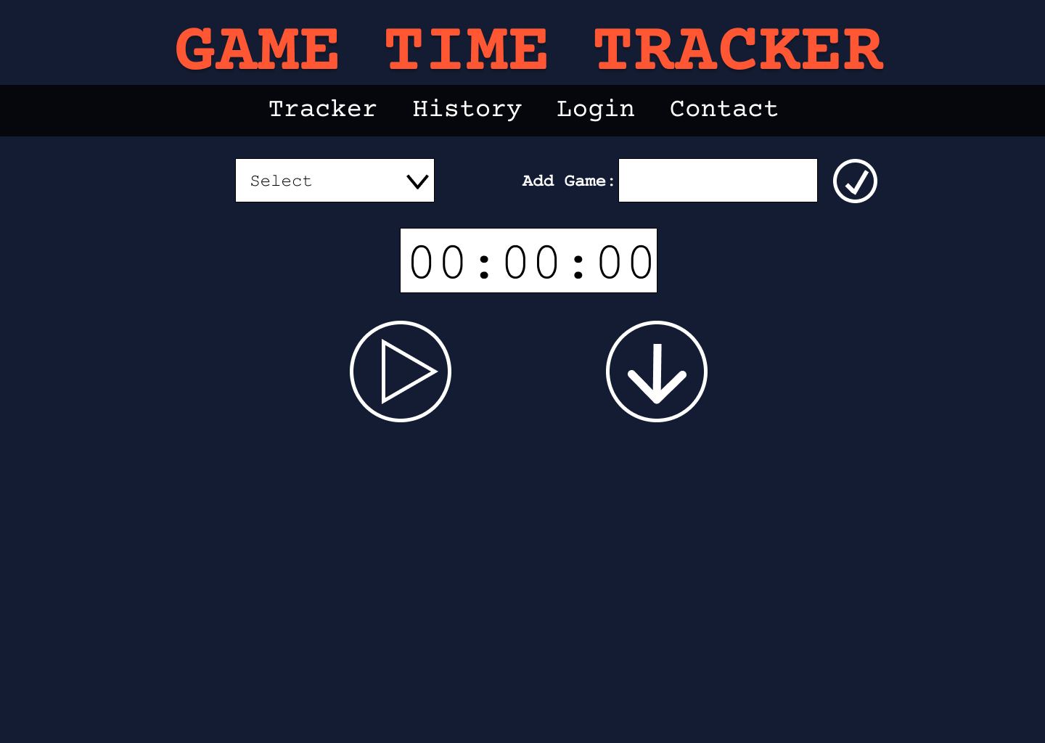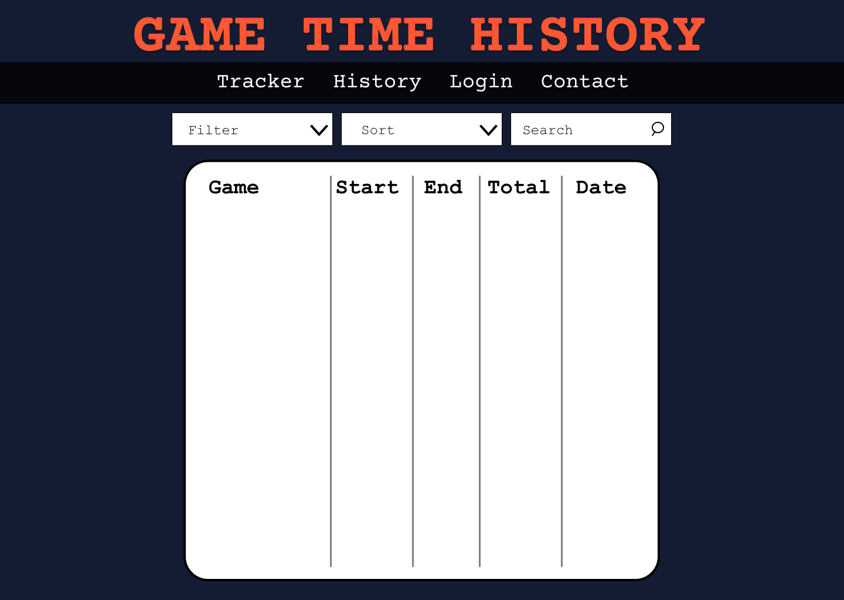 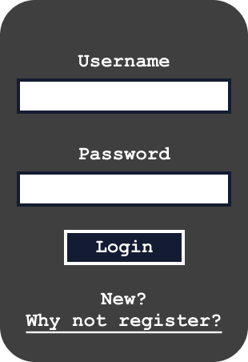

# **Summary of the web system**

The website will be capable of the following tasks

* **User authentication:** User must log in, in order to access their game library and history.
* **Adding Games:** User must be able to add games to save sessions into via text box.
* **Deleting Games:** User must be able to delete games and their history.
* **Play timer and save session:** User must be able to select a game, begin a timer, and then save their session once done.
* **View, sort, filter, and search History:** User must be able to search through their history using a text box, view data from specific games or sort it from most recent or oldest.

# **User Journey**

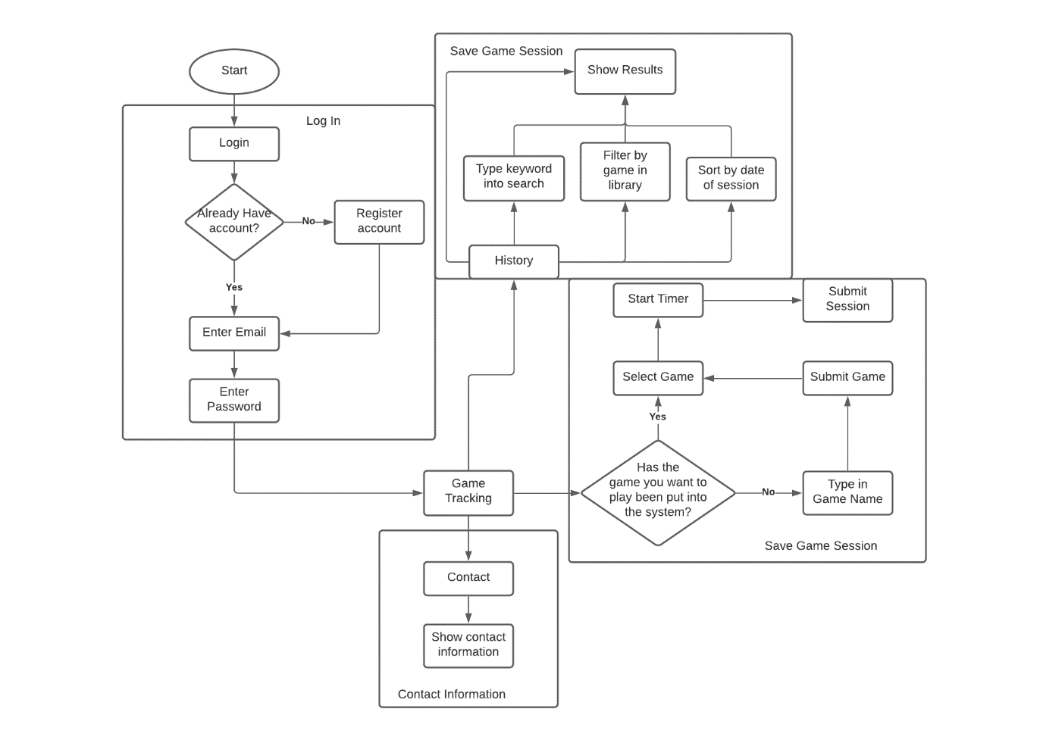

# **Feasibility**

I believe that with the current templates I have created for the website, Should there be no unforeseen circumstances: I should have this website completed in time.